Software Testing Plan

Programming 3 – AT3

Tze yee hon – p466426

2019

Contents

Introduction 2

Program Functionality Test 2

Login Form 2

Sign up and Login 2

Sign up an account 2

Login via correct id and password 3

Login via incorrect id and password 3

Main Form 4

Add button 4

Sort Button 4

Search Button 5

Save Button 6

Open Button 6

Debugging Process 8

# Introduction

The software testing plan is used to test out the features and functionality of the program.

# Program Functionality Test

## Login Form

### Sign up and Login

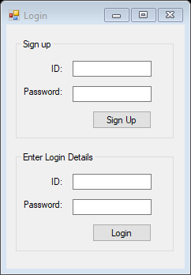

### Sign up an account

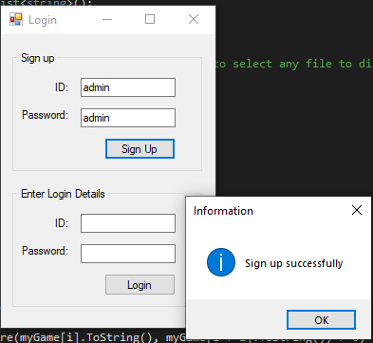

### Login via correct id and password

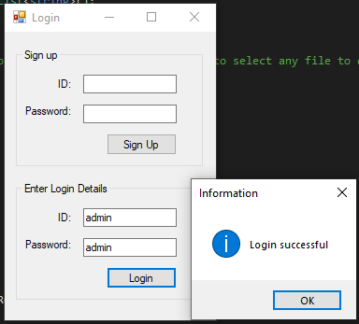

### Login via incorrect id and password

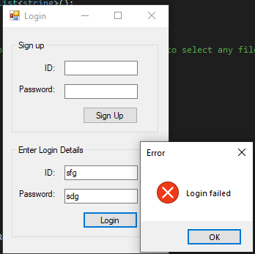

## Main Form

### Add button

Allows user add items into list box

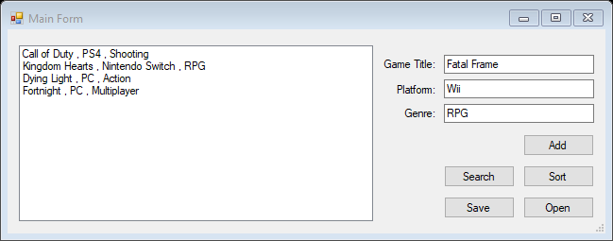

### Sort Button

Allows user to sort items by ascending order

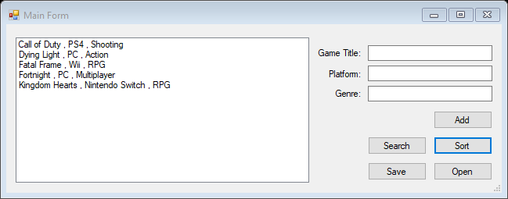

### Search Button

Allows user to search item in list by game title

#### Item existed in list

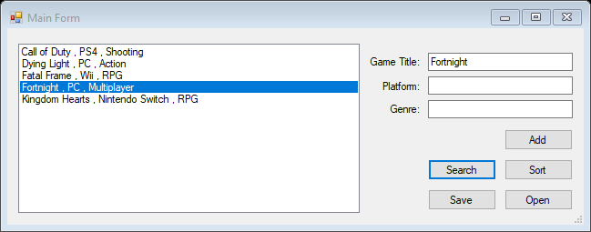

#### Item not existed in list

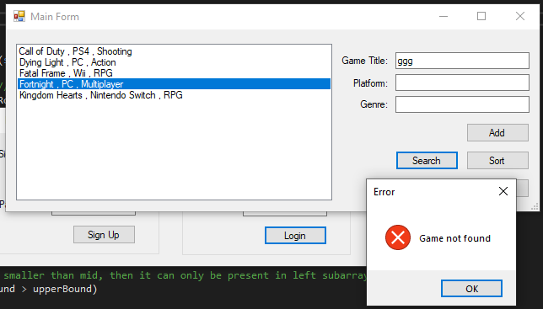

### Save Button

Allows user to save data as csv file

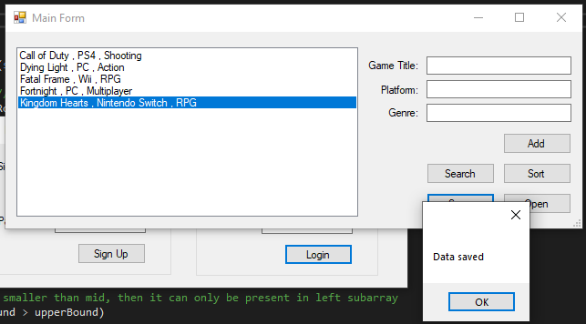

### Open Button

Allows user to display selected csv file

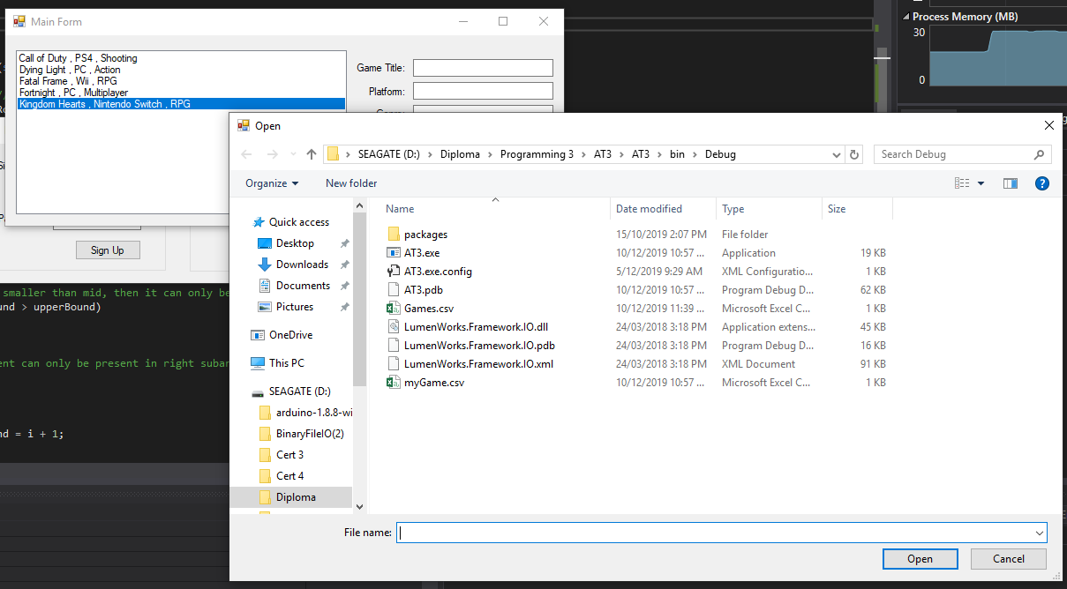

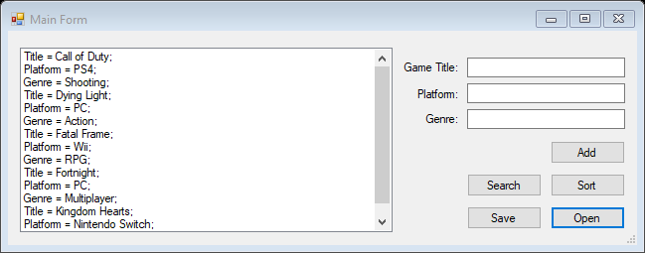

# Debugging Process

Set breakpoint at the first and end of the code that we want to test, run the program and see how the code functions is.

